

School/College/Department t 303 492 0000

Center/Office f 303 492 0000

Building Room Number [email.email@colorado.edu](mailto:email.email@colorado.edu)

000 UCB

Boulder, Colorado 80309-0000

# LAB REPORT : ESD LAB 3

# Signoff Sheet

The figure below shows the sign of sheet for lab 3. Please note that required, supplemental and challenges has been completed for this lab.

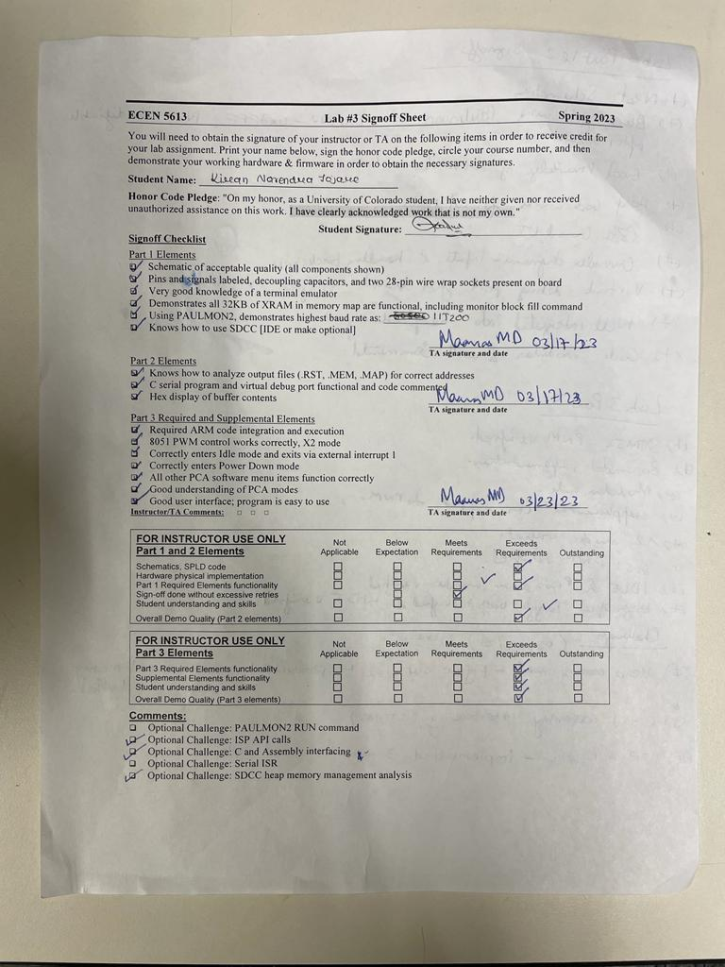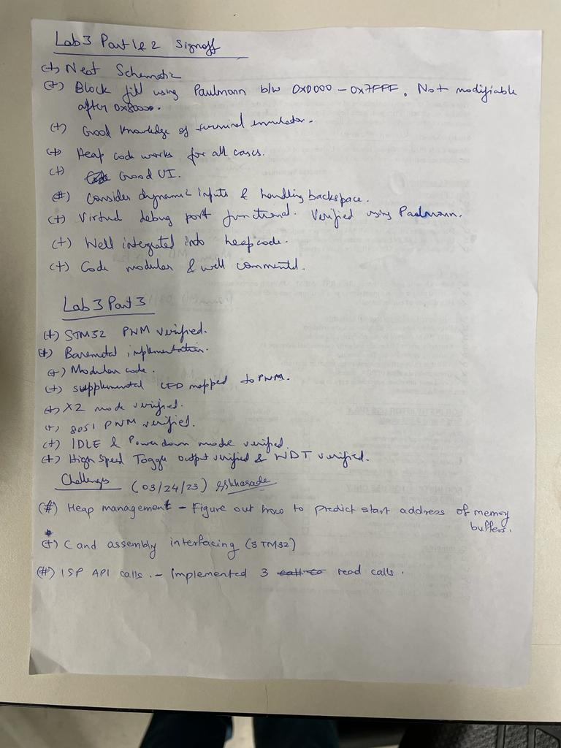

# Board Pictures

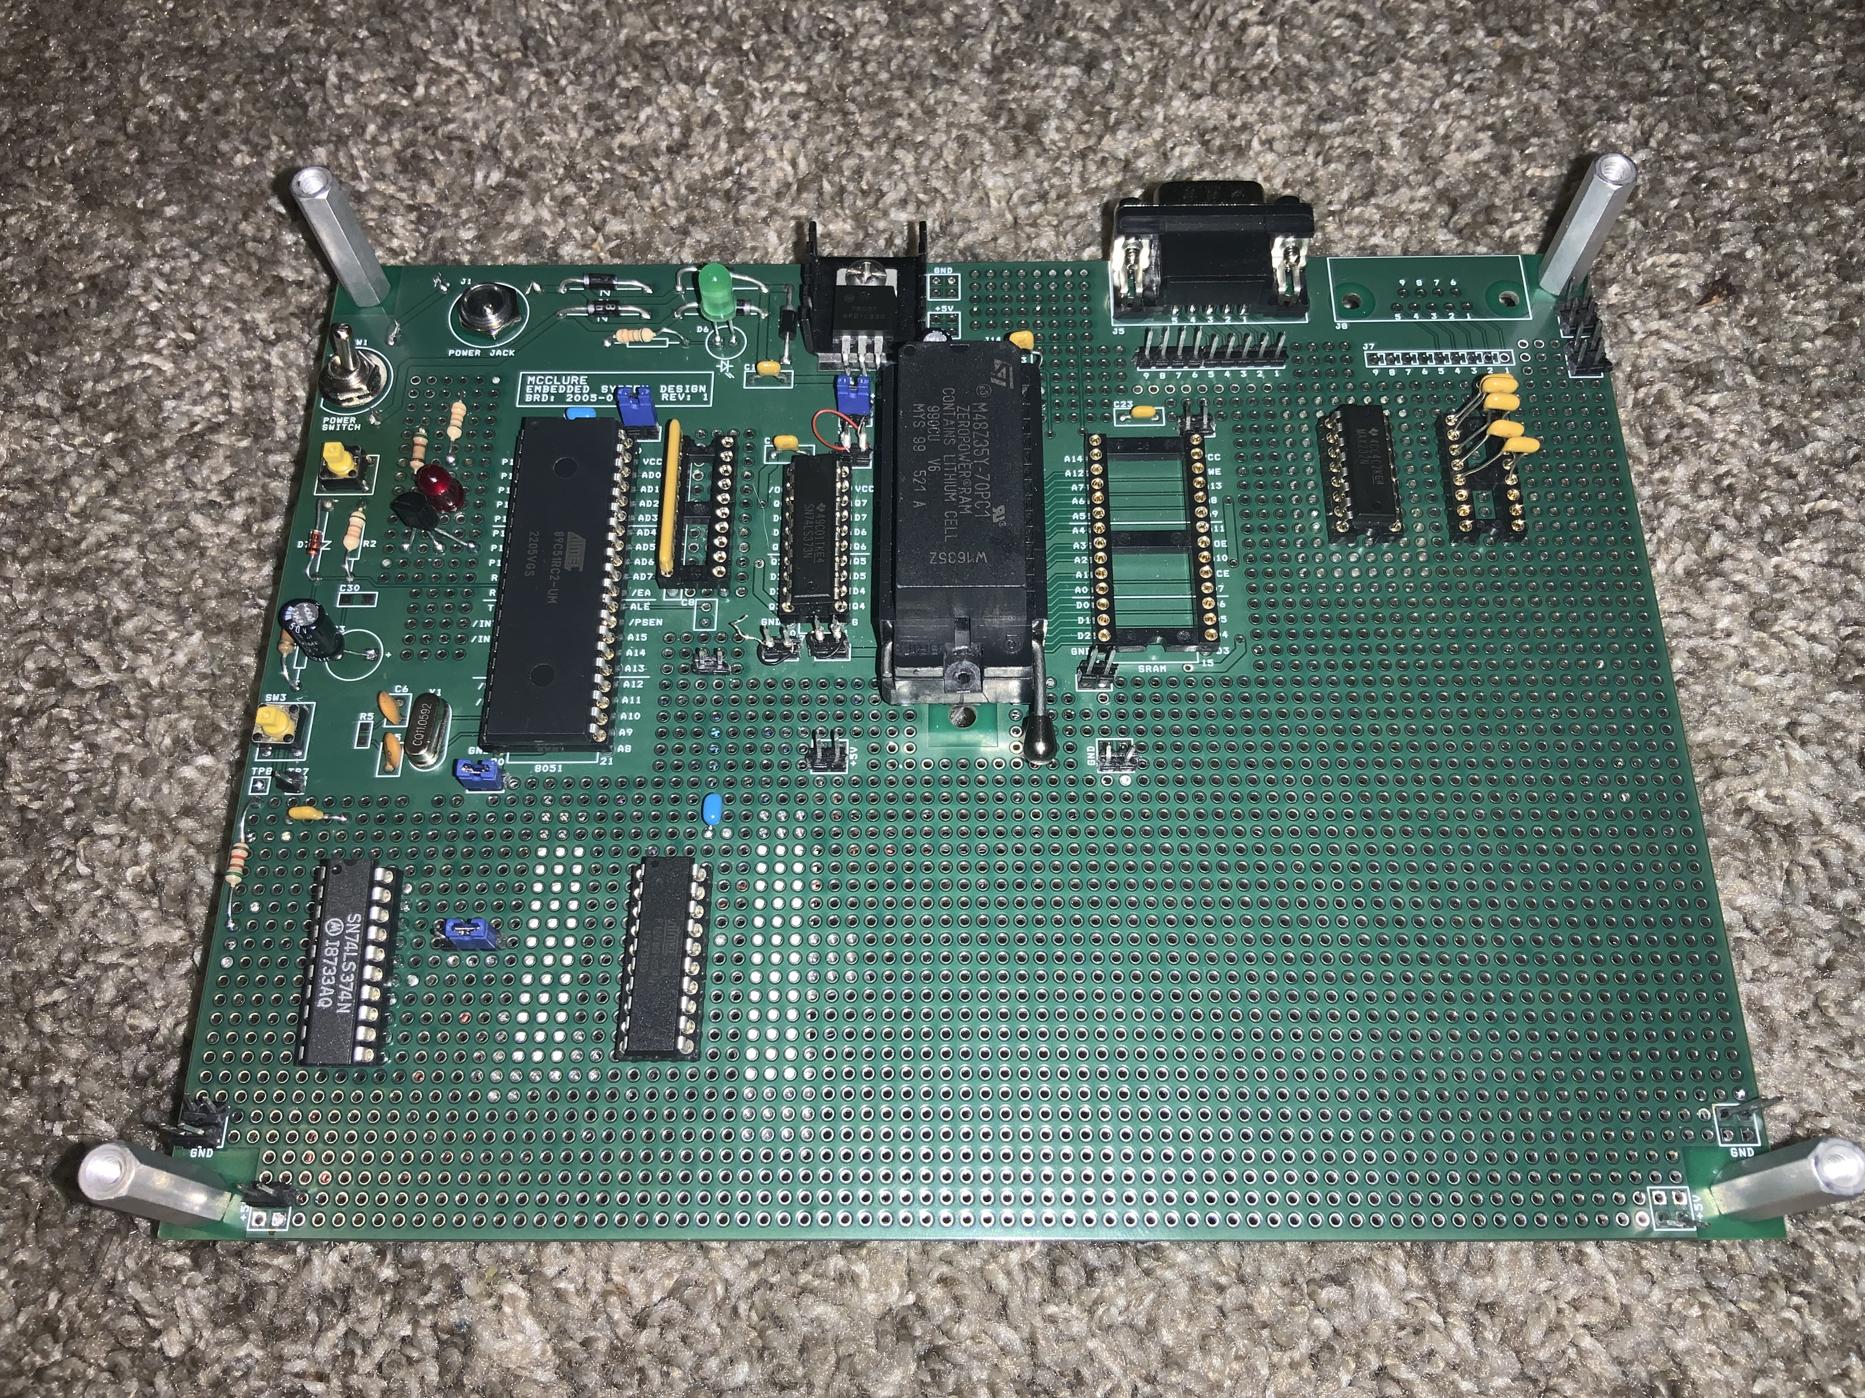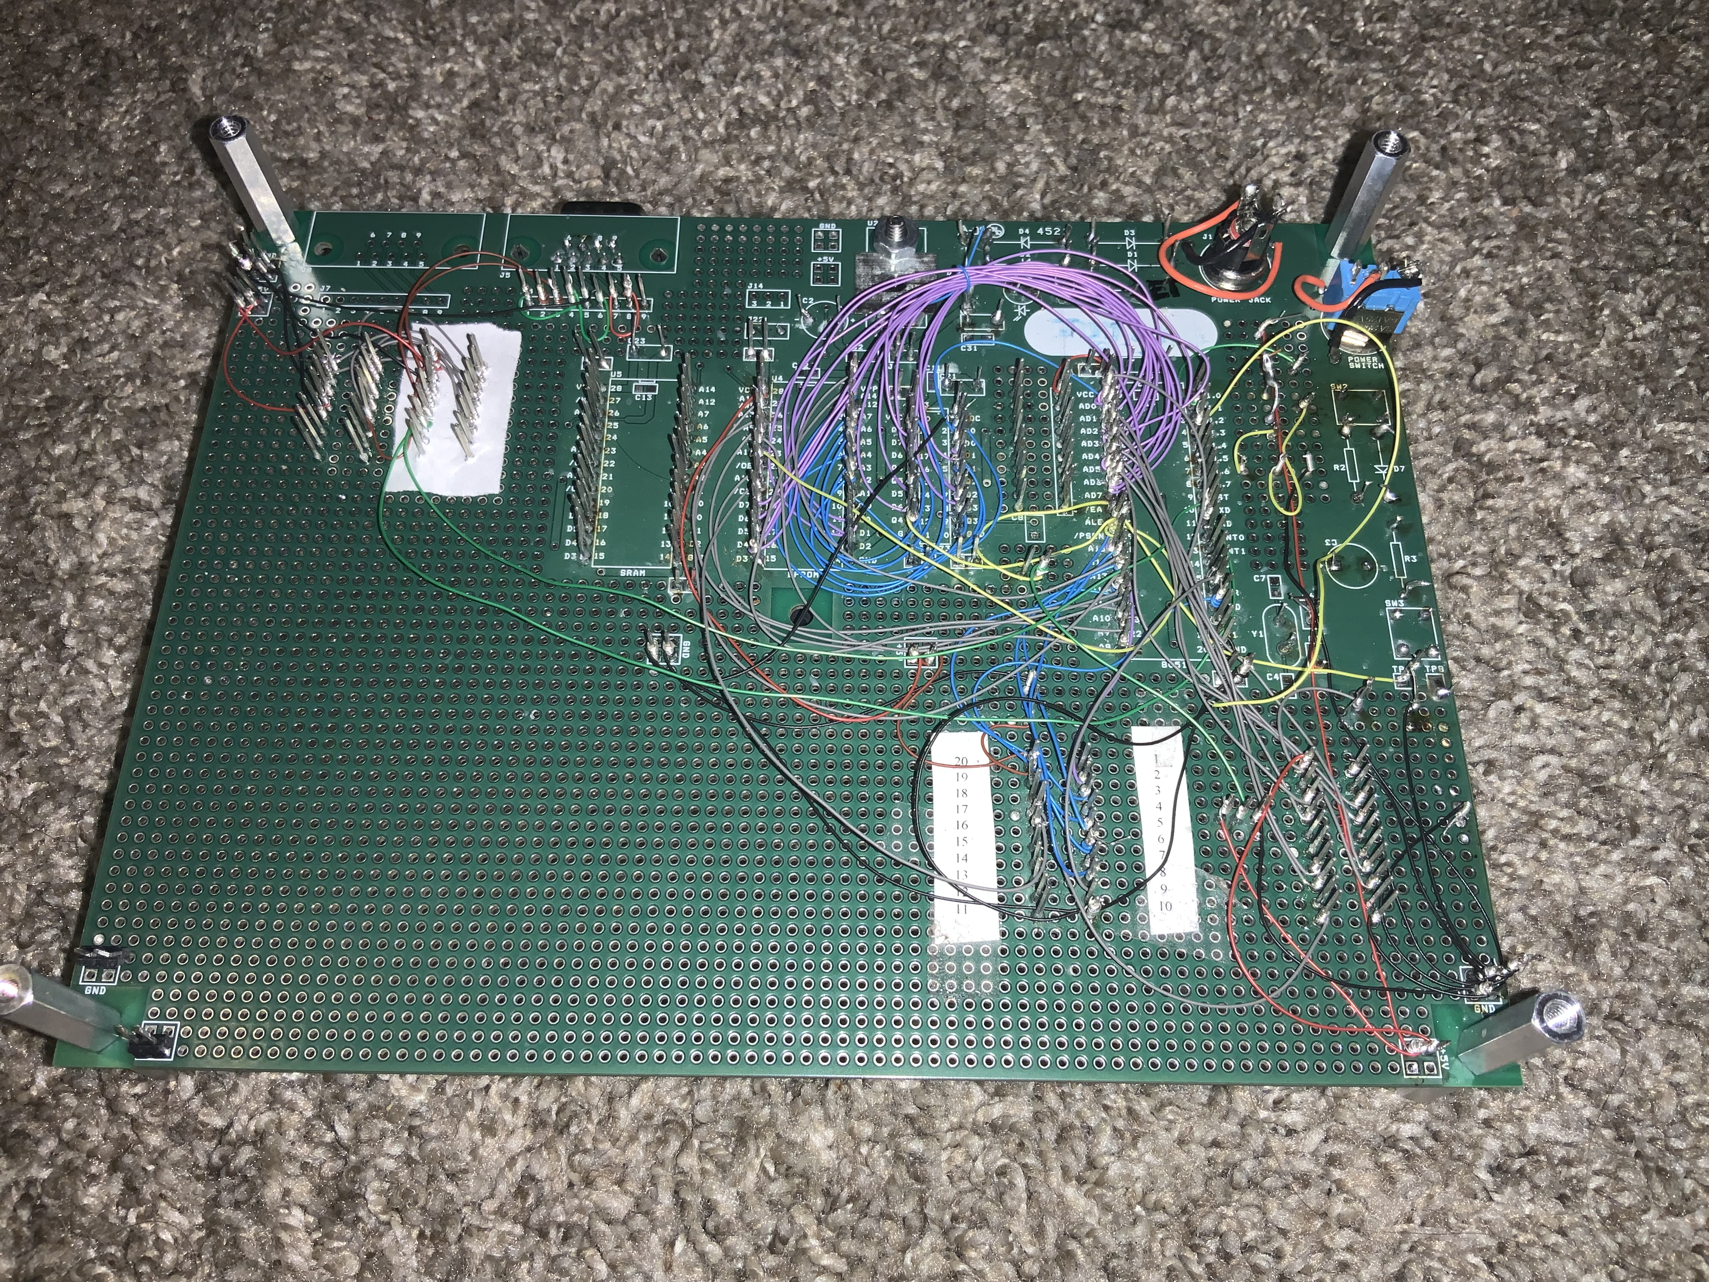

# Lab3 Part 1 (Required)

Configured NVSRAM to use as XRAM data memory. Used and verified PAULMONN. Details are available in sign off sheet and code is available in repo. Own version of PAULMONN assembled to work with A31 assembler.   
  
Maximum Baud Rate Achievable under PAULMONN : 57600  
  
Experimental test SDCC project created and verified during sign off. A sample HEX file is modified and analyzed for SDCC project. Sample code was used to toggle port A pin.

# Lab 2 Part 2 (Required)

The UI for lab 2 part 2 is as shown below. User takes characters and performs specific task as per the requirement. All parts are verified during sign off.

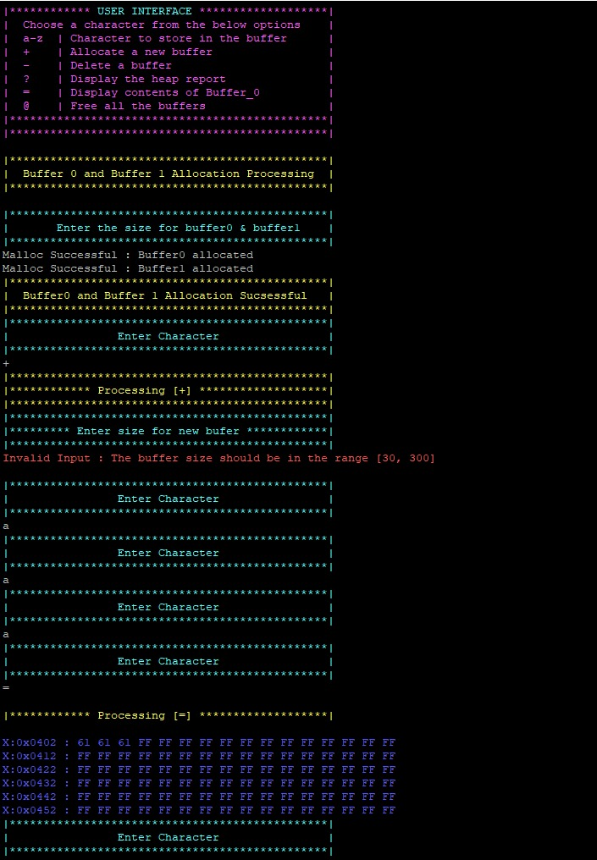

# Lab 2 Part 2 Heap Management Challenge

Click on this file to see the UART log for addresses created during each + and – operation as described by assignment ![UART_LOG](../../../../../../Users/kiran/Downloads/Lab3_Challenge1_SDCC.txt)!  
Step by step Execution :

Step 1) Heap created with 5600 Bytes

Step 2) Buffer 0 and buffer 1 created with 2400 Bytes

Step 3) + command for 200 Bytes

Step 4) + command for 300 bytes

Step 5) – command buffer 2 deleted

This will create an empty buffer space in place of buffer 3   
  
So if new buffer is created with size of 100 it will occupy that free memory space as seen in the heap report seen below  
  
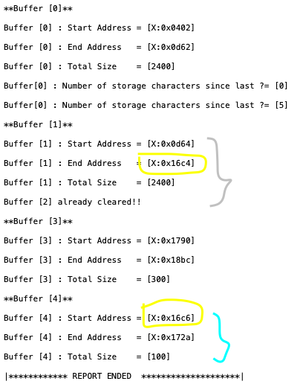

Now if another new buffer is added with 210 bytes length it will be allocated after the after buffer 3 as seen in the figure

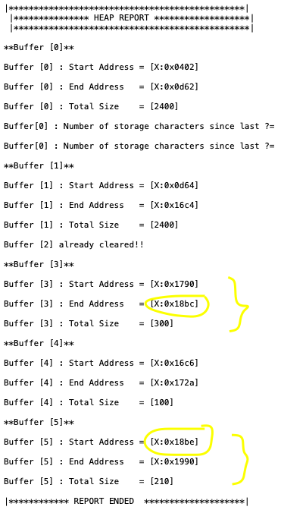

Lastly if one more buffer with the size of 800 bytes is allocated the buffer allocation will fail as malloc will fail to locate free memory in heap as its totally full at this point.

# Lab 3 Part 3 (Required)

The STM output from pin PD15 with default duty cycle of 60% is shown below. PD15 is also connected to a BLUE LED. Output verified during signoff.

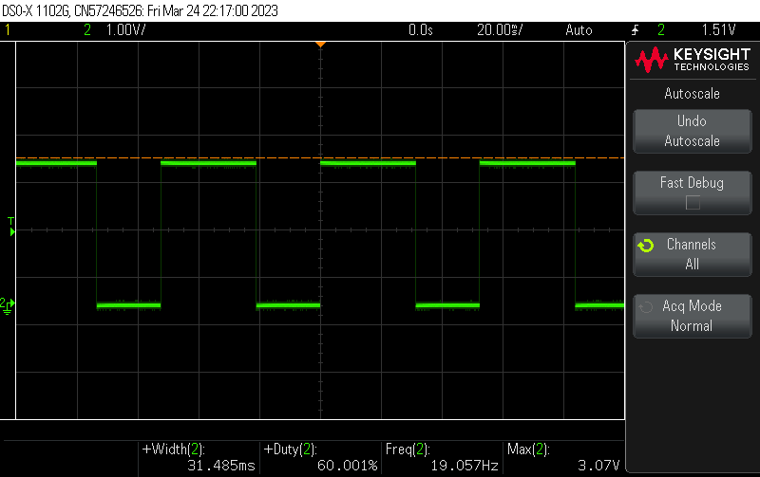

The STM output after switch triggered resulting in duty cycle incrementing by 10% is as follow.

The PWM output increments by 10 % after every button press and decrements by 10% once it reaches maximum. Similarly, the PWM output increments by 10 % till it reaches maximum of 100% again. The behavior has been verified and tested during sign off.

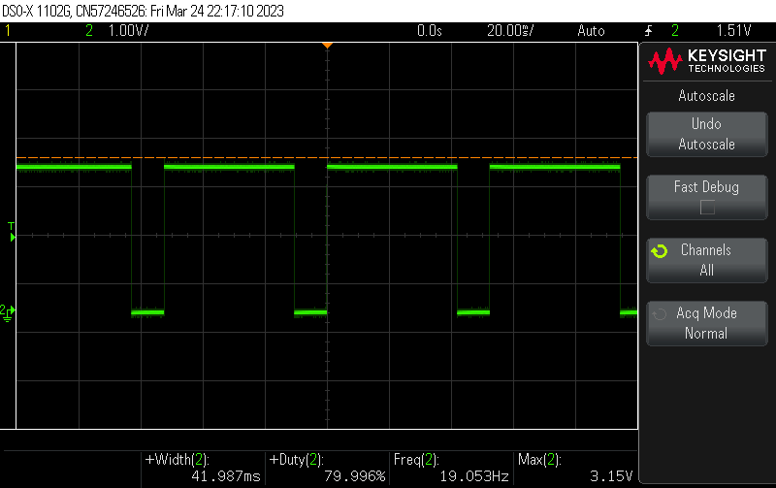

The STM output when character A is pressed over UART UI resulting in duty cycle incrementing by 5% and when B is pressed resulting in decrease in duty cycle by 5% is as follows:

**Incrementing by 5%:**  


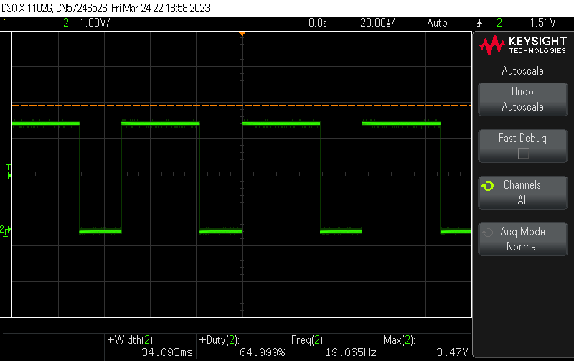

**Decrementing by 5% :**   
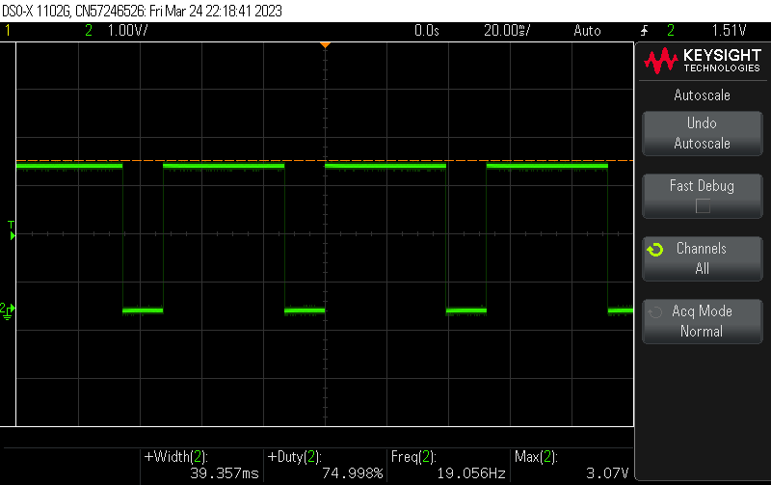

Simple UI repressing the lab 3 part 3 STM part is as below. The sample block is also seen from the picture below.

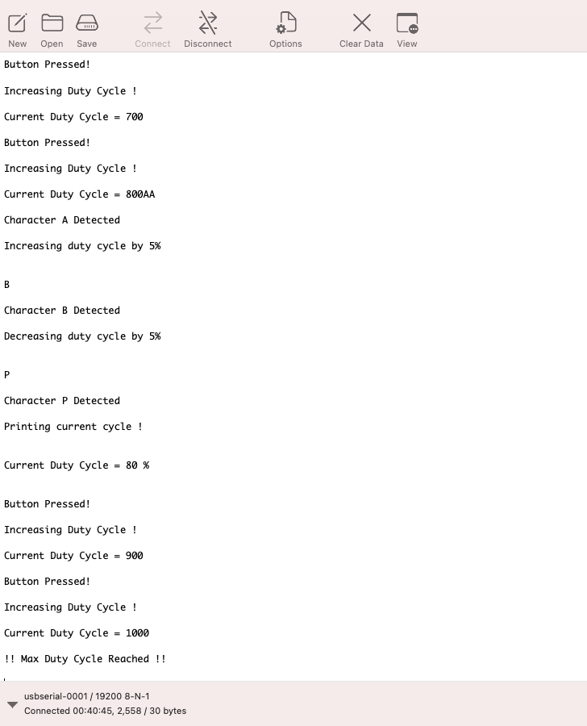

# Lab 3 Part 3 (Supplemental)

Output :

The 8051 outputs for PWM on pin 1.3 are as follows. Running at 33% duty cycle and frequency of X2 mode.

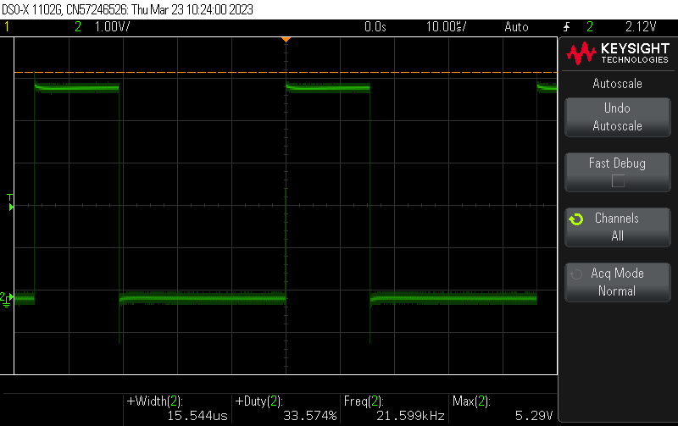

The output with High-Speed toggle output enabled is as follows:

Result makes PWM set to 50% duty cycle i.e. ON for 50% time and OFF for 50%.

The frequency will reach upto 42Hz.

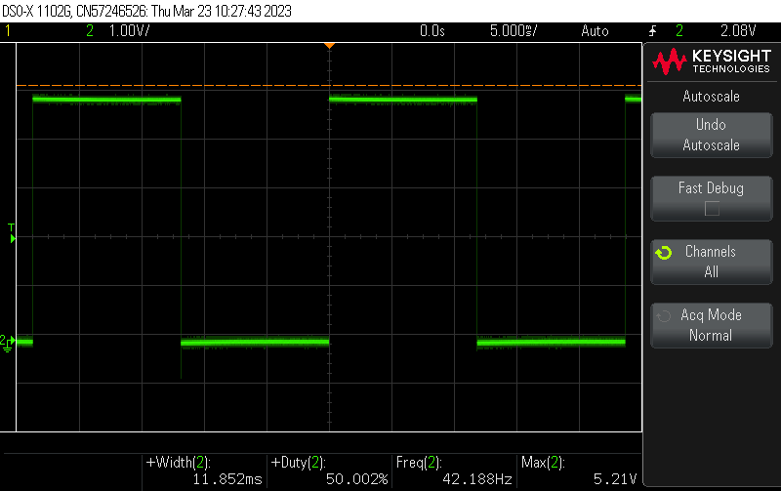

The output with Fclk_periph set to max frequency is as follows. It maintains the frequency of High output mode when triggered. Code also implements power down and Idle mode.   
The requirements are verified and tested for each one of the outputs along with watch dog timer.

Code also implements the IDLE mode and POWERDOWN mode and the firmware to get out of the interrupt using INT0 interrupt. Setting this pin to LOW will make system come out of power down and idle mode.   
  
Code also implements Fclk_periph in minimum and maximum frequency mode as seen in image below.

# Challenges :

**Challenge 2 : ISP Function for AT8951RC2**The code implementing three ISP calls has been implemented to figure out manufacture ID, Device ID1,ID2 and ID3. The UI result is as follows. The values returned matches the values available in data sheet.

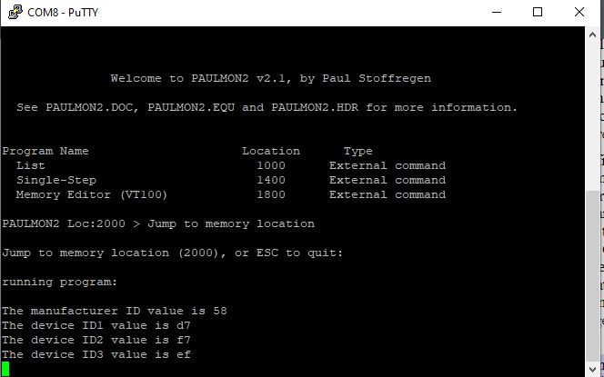

**Challenge 3: C and Assembly Integration**

The code available in challenge folder have a UI which shows how to use an assembly function to calculate ((param2 * param3)modparam1). Along with that its changes the value of global variable set in assembly file in C and show the changes.   
UI from the code is as follows:

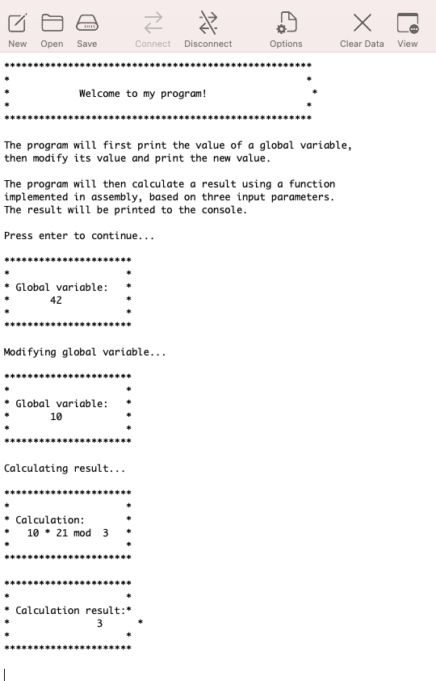

**Challenge 4: Interrupt Driven vs Polling Based UART Driver**

Based on code uploaded interrupt driver UART driver(using FIFO buffer) is found to be much faster than polling based approach. UI output from interrupt driven firmare is as follows:

UART output below shoes the buffering capacity of interrupt driven approach is significantly higher than polling

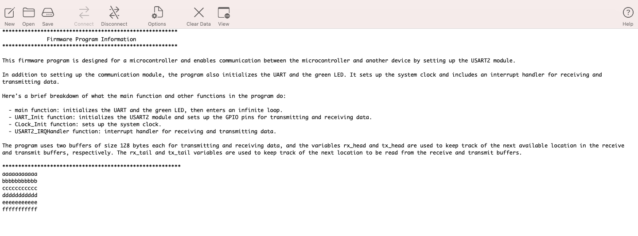

**Challenge 5: SDCC Heap Management**

Malloc’s functionality in heap management has been already discussed in above section called “Lab 2 Part 2 Heap Management Challenge”.

# Submission Questions

1. What operating system (including revision) did you use for your code development?

Mac OS Monterey

1. What compiler (including revision) did you use?

SDCC 2.6.2

1. What exactly (include name/revision if appropriate) did you use to build your code (what IDE, make/makefile, or command line)?

Code Blocks for 8051 part of labs  
STMCube IDE for ARM part of lab

1. Did you install and use any other software tools to complete your lab assignment?

Yes, I had lot of issues with installing putty for MAC. I used an MAC alternative of putty called “CoolTerm”.

1. Did you experience any problems with any of the software tools? If so, describe the problems.

Yes, I had lot of issues with IDE and SDCC environment setup for MAC OS. I was able to install SDCC with MAC environment, but Code Blocks doesn’t support latest or even old version of MAC OS.